**GRAPHS**

A graph is a pictorial representation of a set of objects where some pairs of objects are connected by links. The interconnected objects are represented by points termed as **vertices**, and the links that connect the vertices are called **edges**.

Formally, a graph is a pair of sets **(V, E)**, where **V** is the set of vertices and **E** is the set of edges, connecting the pairs of vertices. Take a look at the following graph −

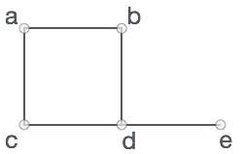

**Graph Data Structure**

Mathematical graphs can be represented in data structure. We can represent a graph using an array of vertices and a two-dimensional array of edges. Before we proceed further, let's familiarize ourselves with some important terms −

* **Vertex** − Each node of the graph is represented as a vertex. In the following example, the labelled circle represents vertices. Thus, A to G are vertices. We can represent them using an array as shown in the following image. Here A can be identified by index 0. B can be identified using index 1 and so on.
* **Edge** − Edge represents a path between two vertices or a line between two vertices. In the following example, the lines from A to B, B to C, and so on represents edges. We can use a two-dimensional array to represent an array as shown in the following image. Here AB can be represented as 1 at row 0, column 1, BC as 1 at row 1, column 2 and so on, keeping other combinations as 0.
* **Adjacency** − Two node or vertices are adjacent if they are connected to each other through an edge. In the following example, B is adjacent to A, C is adjacent to B, and so on.
* **Path** − Path represents a sequence of edges between the two vertices. In the following example, ABCD represents a path from A to D.

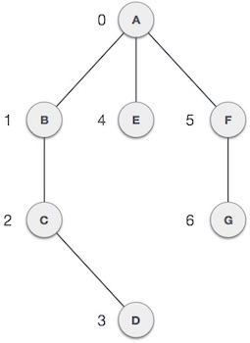

**Basic Operations**

Following are basic primary operations of a Graph −

* **Add Vertex** − Adds a vertex to the graph.
* **Add Edge** − Adds an edge between the two vertices of the graph.
* **Display Vertex** − Displays a vertex of the graph.

# **Graph Representations**

In graph theory, a graph representation is a technique to store graph into the memory of computer.

To represent a graph, we just need the set of vertices, and for each vertex the neighbors of the vertex (vertices which is directly connected to it by an edge). If it is a weighted graph, then the weight will be associated with each edge.

There are different ways to optimally represent a graph, depending on the density of its edges, type of operations to be performed and ease of use.

1. **Adjacency Matrix**

* Adjacency matrix is a sequential representation.
* It is used to represent which nodes are adjacent to each other. i.e. is there any edge connecting nodes to a graph.
* In this representation, we have to construct a nXn matrix A. If there is any edge from a vertex i to vertex j, then the corresponding element of A, ai,j = 1, otherwise ai,j= 0.
* If there is any weighted graph then instead of 1s and 0s, we can store the weight of the edge.

### **Example**

Consider the following **undirected graph representation**:

**Undirected graph representation**

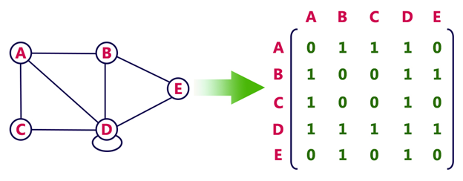

**Directed graph Represenation**

See the directed graph representation:

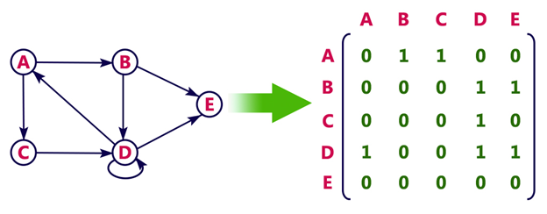

In the above examples, 1 represents an edge from row vertex to column vertex, and 0 represents no edge from row vertex to column vertex.

**Undirected weighted graph representation**

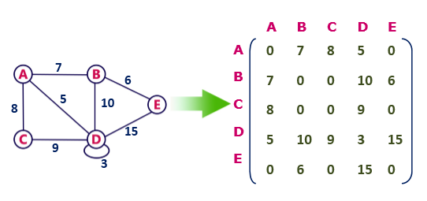

**Pros:** Representation is easier to implement and follow.

**Cons:** It takes a lot of space and time to visit all the neighbors of a vertex, we have to traverse all the vertices in the graph, which takes quite some time.

## 2. Incidence Matrix

In **Incidence matrix representation**, graph can be represented using a matrix of size:

Total number of vertices by total number of edges.

It means if a graph has 4 vertices and 6 edges, then it can be represented using a matrix of 4X6 class. In this matrix, columns represent edges and rows represent vertices.

This matrix is filled with either **0 or 1** or -1. Where,

* 0 is used to represent row edge which is not connected to column vertex.
* 1 is used to represent row edge which is connected as outgoing edge to column vertex.
* -1 is used to represent row edge which is connected as incoming edge to column vertex.

### **Example**

Consider the following directed graph representation.

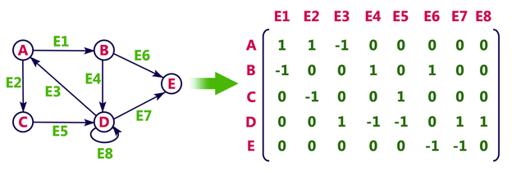

## Adjacency List

* Adjacency list is a linked representation.
* In this representation, for each vertex in the graph, we maintain the list of its neighbors. It means, every vertex of the graph contains list of its adjacent vertices.
* We have an array of vertices which is indexed by the vertex number and for each vertex v, the corresponding array element points to a **singly linked list** of neighbors of v.

### **Example**

Let's see the following directed graph representation implemented using linked list:

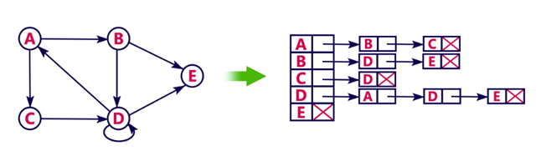

We can also implement this representation using array as follows:

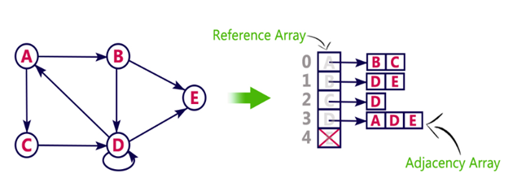

**Pros:**

* Adjacency list saves lot of space.
* We can easily insert or delete as we use linked list.
* Such kind of representation is easy to follow and clearly shows the adjacent nodes of node.

**Cons:**

* The adjacency list allows testing whether two vertices are adjacent to each other but it is slower to support this operation.

**RELEVANT READING MATERIAL AND REFERENCES:**

**Source Notes:**

1. <https://www.tutorialspoint.com/data_structures_algorithms/graph_data_structure.htm>
2. <https://www.javatpoint.com/graph-theory-graph-representations>

**Lecture Video:**

* 1. <https://www.youtube.com/watch?v=5hPfm_uqXmw>
  2. <https://www.youtube.com/watch?v=1n5XPFcvxds&list=PLqM7alHXFySEaZgcg7uRYJFBnYMLti-nh>

**Online Notes:**

1. <http://www.crectirupati.com/sites/default/files/lecture_notes/ds%20ln.pdf>
2. <http://www.vssut.ac.in/lecture_notes/lecture1428550942.pdf>

**Text Book Reading:**

1. Cormen, Leiserson, Rivest, Stein, “*Introduction to Algorithms*”, Prentice Hall of India, 3rd edition 2012. problem, Graph coloring.
2. Lipschutz, S., “*Data Structures, Schaum's Outline Series*”, Tata McGraw Hill.

**Online Book Reference:**

1. <https://www.edutechlearners.com/download/books/DS.pdf>

**In addition: PPT can be also be given.**